
JC2 PRELIMINARY EXAMINATION [MARK SCHEME]
TAMPINES MERIDIAN JUNIOR COLLEGE

CANDIDATE
NAME
CIVICS GROUP
_________________________________________________________________________________
H2 GEOGRAPHY 9173/02
Paper 2 21 September 2026 3 Hours
Additional Materials: 12 Page Answer Booklet
1 Insert ____________________________________________________________________________

READ THESE INSTRUCTIONS FIRST

Write your answers in the answer booklet provided. You should follow the instructions on the front cover of the answer booklet. If you need additional answer paper, ask the invigilator for a continuation booklet.

Answer all questions.

The Insert contains all the Resources referred to in the questions.
You should make a reference to appropriate examples studied in the field or the classroom, even where the examples are not specifically requested by the question.
Diagrams and sketch maps should be drawn wherever they serve to illustrate an answer.
You are reminded of the need for good English and clear presentation in your answers.

The number of marks is given in the brackets [ ] at the end of each question or part question.

______________________________________________________________________
This document consists of 5 printed pages and 1 blank page.

Answer Questions 1 and 2 and
EITHER Question 3 OR Question 4

Section A

Cluster 4 Fieldwork

1 | A group of 10 students wanted to investigate if Singapore’s car-lite plan to reduce carbon emissions have managed to encourage more walking and cycling in Singaporeans. They decided to survey Singaporean residents in Punggol and Serangoon.  The students agreed to the following hypothesis:  Residents in Punggol are more likely to walk and cycle than residents in Serangoon.  The students researched on the internet for some basic information about the locations.  They produced a questionnaire survey to collect information about the needs of 20 residents in each of the location as shown in Site A (Punggol Waterway Point) and Site B (Serangoon Nex). Site A is a popular shopping centre in Punggol next to a park connector for walking and cycling. Site B is a popular shopping centre in Serangoon next to various amenities but not near to any park connectors.  They decided to use a systematic sampling method, standing outside both shopping centre entrance and asking every fifth person that walked out of the shopping centre on a Tuesday in June to help complete their questionnaire survey, they stood from 1pm to 4pm and collected responses from 20 residents in each location.  Resource 1 shows the location of the two survey neighbourhoods in Singapore. Resource 2A and 2B shows their actual survey location outside Punggol Waterway Point and Serangoon Nex. Resource 3 shows the questionnaire survey administered by the students. Resource 4 shows part of the results collected by the students.

 | (a) | Explain one strength and one weakness in the students’ hypothesis.  Strength: Capable of research: clearly defined independent variable (location) and dependent variable (Likelihood of walking and cycling)  Weakness: Ambitious dependent variable walking and cycling | [4]
 | (b) | Explain how the students can minimise potential risks they might encounter when conducting their fieldwork in the two neighbourhoods shown in Resource 2A and 2B.  2m per explanation  Weather related risks – hydration, breaks, appropriate attire  Traffic related risk in 2B – vigilance when crossing the road  Collision with people – stand at one side to conduct survey | [4]
 | (c) | With reference to resource 1, 2A and 2B, explain the strengths and weaknesses of the students’ choice of the neighbourhood in which the residents were surveyed.  Strengths:  Relatively close proximity to each other in the east of Singapore  High pedestrian traffic (ease of obtaining respondents)  Weaknesses: Bias: 2A is next to cycling path, 2B is next to the MRT station | [6]
 | (d) | Explain the limitations of the sampling method used by students.  Too few samples  Timing of survey biased  Systematic sampling may result in over-representation of particular population subgroups | [6]
 | (e) | Explain three ways in which the data collection sheet shown in Resource 3 can be improved.  Privacy: age can be replaced by age range  Ambiguity: Quantify options for Q3 and Q4  Likert scale for Q5 | [6]
 | (f) | Using a suitable data representation method, show the responses of Punggol and Serangoon residents to question 4 as reflected in Resource 4. | [4]
Comparative bar graph or
2 separate pie charts

 | (g) | With reference to the resources, evaluate the validity of the students’ fieldwork and suggest if the hypothesis is valid.  Candidates should present a clear stand on the validity consider the validity of the hypothesis considering the scope and rigour of the fieldwork, paying particular attention to the reliability and accuracy of the data collected and its usefulness in justifying the validity of the hypothesis.  Marked according to Generic Level Descriptors for H2 Fieldwork Evaluative Question | [10]
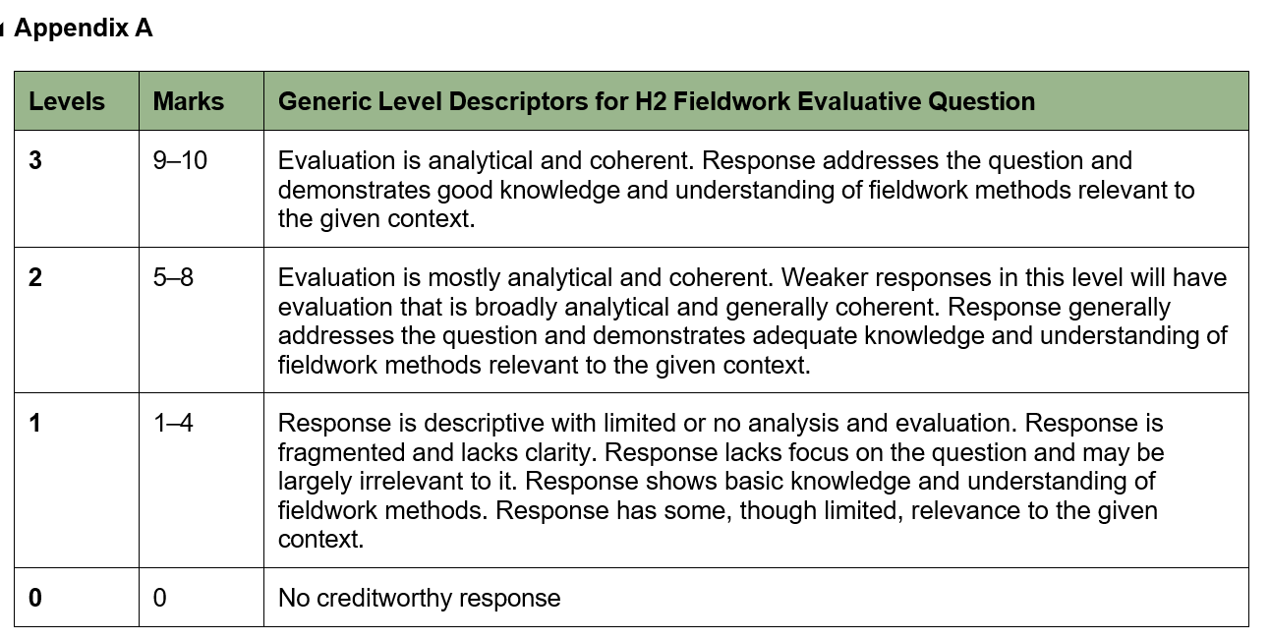

Section B

Cluster 3 Sustainable Future and Climate Change

2 | Resource 5 shows the carbon dioxide (CO₂) emissions per capita of selected countries. Resource 6 shows a cartoon portraying the impact of climate change. Resource 7 shows an urban slum in Manila, Philippines.
 | (a) | Using Resource 5, describe the changes in carbon dioxide (CO₂) emissions per capita from 1960 to 2024. | [4]
- General decline for most countries
- Increase for India and China
- Uneven change
- Variations in increase and decrease

 | (b) | Account for the changes in carbon dioxide (CO₂) emissions per capita for different countries shown in Resource 5.  - India and China: Industrialisation and increasing affluence  - European Union and UK: adoption of alternative energy resources  - China growth after 2000: Opening up of Chinese economy | [6]
 | (c) | With reference to Resource 6, suggest reasons why the impact of climate change varies between wealthy and poor nations.  - Ability to afford adaptation strategies  - Vulnerability to sea level rise  - Vulnerability to extreme weather events | [6]
 | (d) | Using Resource 7, describe the characteristics of the slum dwelling in Manila, Philippines. | [4]
- Unhygienic (lacking sanitation)
- Dangerous (flimsy/poorly constructed)
- Congested
- Vulnerable to flooding

 | (e) | With reference to Resource 7, suggest how the presence of slums would affect sustainable urban development in Manila, Philippines.  - Unhygienic conditions contribute to pollution and is adverse to environmental integrity.  - Unsightly and polluted living conditions deter inward FDI and jeopardise economic vibrancy  - Poverty in slums hinder social-well being | [6]
 | (f) | Explain two economic reasons why cities engage in urban reimaging efforts. | [4]
- To reverse urban obsolesce of built infrastructure
- To increase economic vibrancy by attracting investment

Section C
Answer EITHER question 3 OR question 4
3 | ‘States are the most important actors in climate change response.’  Evaluate this statement.  Candidates can approach the question by making a judgment on the importance of states relative to the other actors (Firms and NGOs) in BOTH mitigating and adapting to climate change. Candidates can consider a range of roles that the different actors play and their complementarity. An overarching understanding that can be applied to this response is how climate change involves complex inter-relationships between the actors.  Levels marked using Generic Level Descriptors for H2 Essays | [20]
4 | Evaluate the factors influencing the liveability of cities.  Candidates can approach the question by presenting a nuanced response considering the relative importance of economic factors, social factors and environmental factors in influencing the liveability of cities for different groups of people within the city (eg women and elderly). An overarching understanding that can be applied to this response is how liveability is extremely subjective and varies considerably over time, as well as over space within the city.  Levels marked using Generic Level Descriptors for H2 Essays | [20]
Levels | Marks | Generic Level Descriptors for H2 Essays
5 | 18–20 | Evaluation is consistently analytical and coherent. Response is well-supported by relevant material, including the effective use of examples. Response features accurate geographical knowledge and reflects good understanding of the subject content relevant to the question.
4 | 14–17 | Evaluation is analytical and coherent. Response is mostly well-supported by relevant material, including the appropriate use of examples. Response features accurate geographical knowledge and reflects adequate understanding of the subject content relevant to the question.
3 | 10–13 | Evaluation is broadly analytical and generally coherent. Response is moderately well- supported by relevant material, including some appropriate use of examples.  Response features accurate geographical knowledge and reflects adequate understanding of the subject content relevant to the question.
2 | 6–9 | Response is largely descriptive with limited analysis and evaluation. Response is partly coherent and may lack clarity in parts. Response is poorly supported by relevant materials, including the limited use of examples. Response features inaccurate geographical knowledge and poor understanding of the subject content relevant to the question.
1 | 1–5 | Response is descriptive with no analysis or evaluation. Response is fragmented and lacks clarity. Response consists of unsupported assertions. Response features largely inaccurate geographical knowledge and a lack of understanding of the subject content relevant to the question.
0 | 0 | No creditworthy response

Blank Page

